Anti-Inflammatory
Sweet cherries are high in anthocyanins which may shut down enzymes that cause tissue inflammation. Research shows that cherry consumption reduces biomarkers and C-reactive protein of inflammation caused by many chronic diseases, including arthritis, diabetes, cancer, hypertension, cardiovascular disease.

Goodbye Gout Attacks
Gout is a painful form of arthritis caused by elevated levels of uric acid in the blood. It affects more than 8.3 million Americans. USDA Western Human Nutrition Research Center research found that eating sweet cherries may lower the levels of uric acid in the blood. A study at the Boston University School of Medicine reports patients who eat cherries and take their medicine have a 35% to 75% lower chance of experiencing an attack.

Cancer-Fighting Properties
Cherries contain ellagic acid and anthocyanins, which may inhibit the growth of cancer cells. There is more research happening to find out the phytonutrient powers of sweet cherries.

Regulate Sleep Patters
Cherries are one of the few plant sources of melatonin. Research suggests that eating a handful of cherries about an hour before bedtime may help regulate sleep patterns. Cherries would be a great food to consider when trying to battle jet lag.

Fiber Filled
A cup of sweet cherries delivers about 3 grams of dietary fiber, or about 12 percent of the daily value from USDA Dietary Guidelines. Fiber contributes to maintaining a healthy weight, diabetes prevention, and improved cardiovascular health.

Low on the Glycemic Index
Cherries have a lower glycemic index score than many other fruits. That means they release glucose slowly and evenly, so blood sugar levels don’t spike.

California Cherry Season
- Dark-sweet cherries come off the trees in our California orchards during the month of May
- This season, customers can expect to find large sizes, dark colors and overall quality to be excellent which will make cherry fans very happy!
- California’s dark-sweet cherries come with an explosion of flavor! They are sweet with hints of acid that lead to an unforgettable and tasty experience.

Social Posts
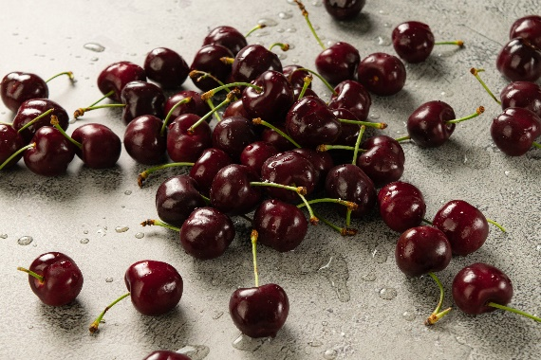
Facebook/Twitter
Have you heard? Cherries are back in season! Cherries from @Stemilt’s California orchards are coming off the tree as we speak and they are ready to be devoured! Did you know cherries have anti-inflammatory properties thanks to anthocyanins, an antioxidant the cherry naturally possesses?

@Stemilt cherries are back! These large, flavorful dark-sweet cherries are coming straight from Stemilt’s California orchards and they sure are delicious and the perfect nutritious snack! Fullof good-for-you nutrients like fiber, potassium and Vitamin C! Don’t forget to grab a bag or three the next time you head to [STORE NAME]. They won’t last long!
[PRODUCE DEPARTMENT PHOTO/VIDEO OF PRODUCT]

Instagram
Did you know dark-sweet cherries have anti-inflammatory properties thanks to anthocyanins, (a group of antioxidants)? This sweet treat is not only delicious but also very nutritious and is back in season. Come grab a bag today!
#cherries #worldfamous #worldfamouscherries #yesplease #summerfood #nutritious #healthysnacking #snacking #kidfriendlysnacking

Cherries are back! These delicious and nutritious summer gems are the perfect sweet snack without the added sugar. Plus, they are full of good-for-you nutrients like fiber, potassium and Vitamin C. Don’t forget to grab a bag or three the next time you head to [STORE NAME]. They won’t last long!
#cherries #worldfamous #worldfamouscherries #yesplease #summerfood #nutritious #healthysnacking #snacking #kidfriendlysnacking
[PRODUCE DEPARTMENT PHOTO/VIDEO OF PRODUCT]

